

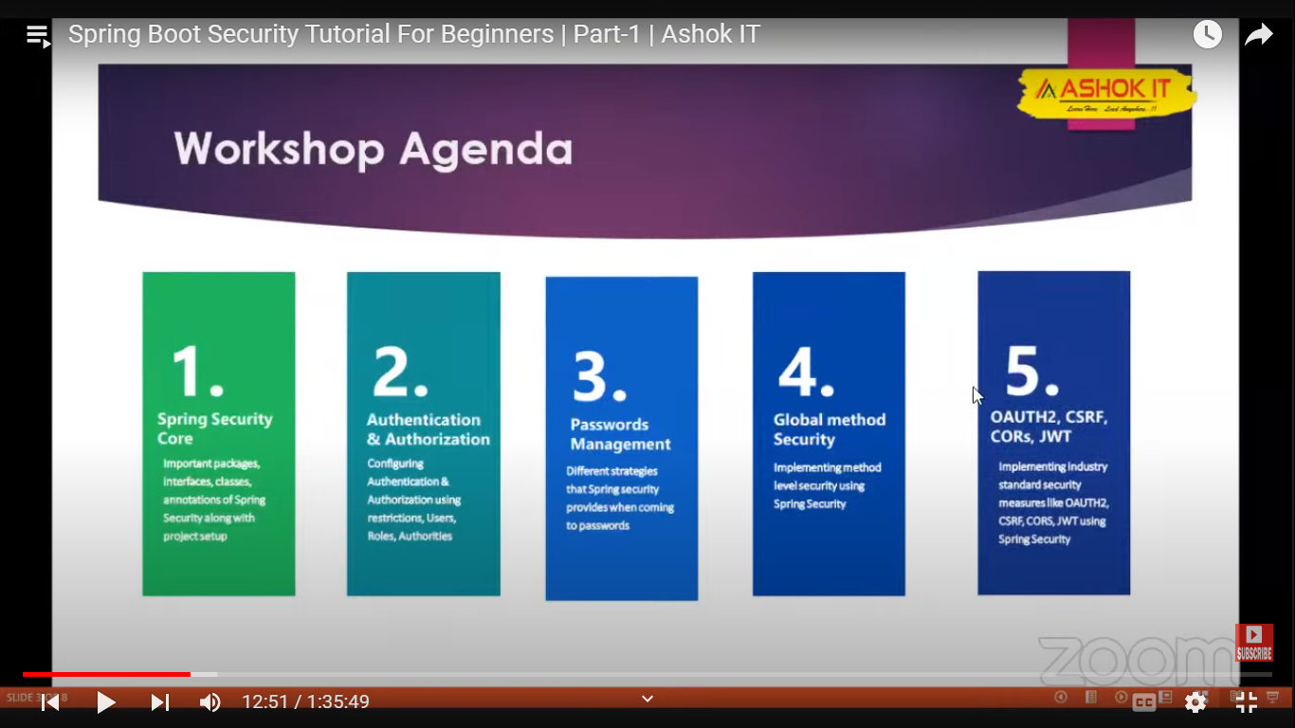

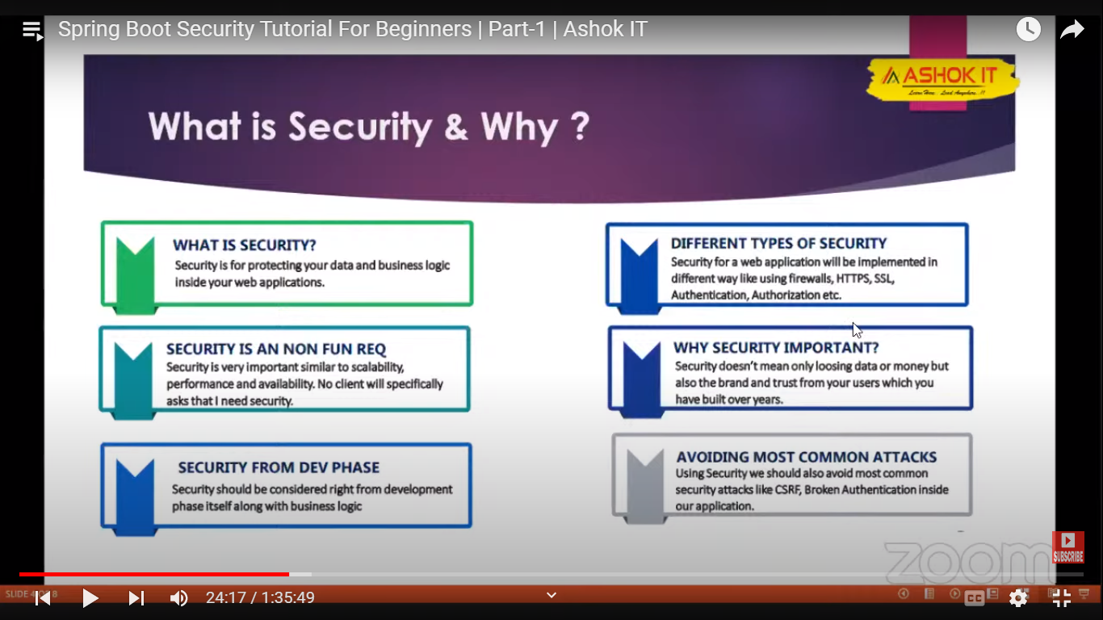

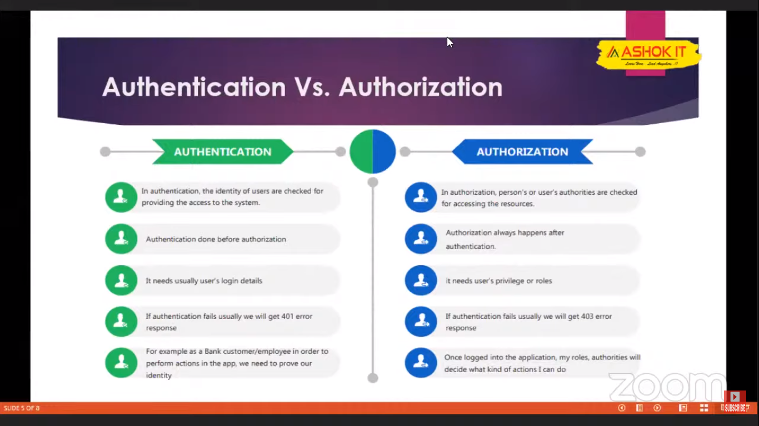

**Implementation:**

**Step 1:** Create spring boot project

**Step 2:** Add security dependency

**Step 3:** Create our rest API

**Step 4:** Hit the service from browser



**Step 5:** Password will be generated in the console

**NOTE:** After successlogin, the cred will be stores in cookies. If we try to access the API multiple times in the same browser, it will use the stored cred.

If we try some other browser login page will be displayed for the first time.

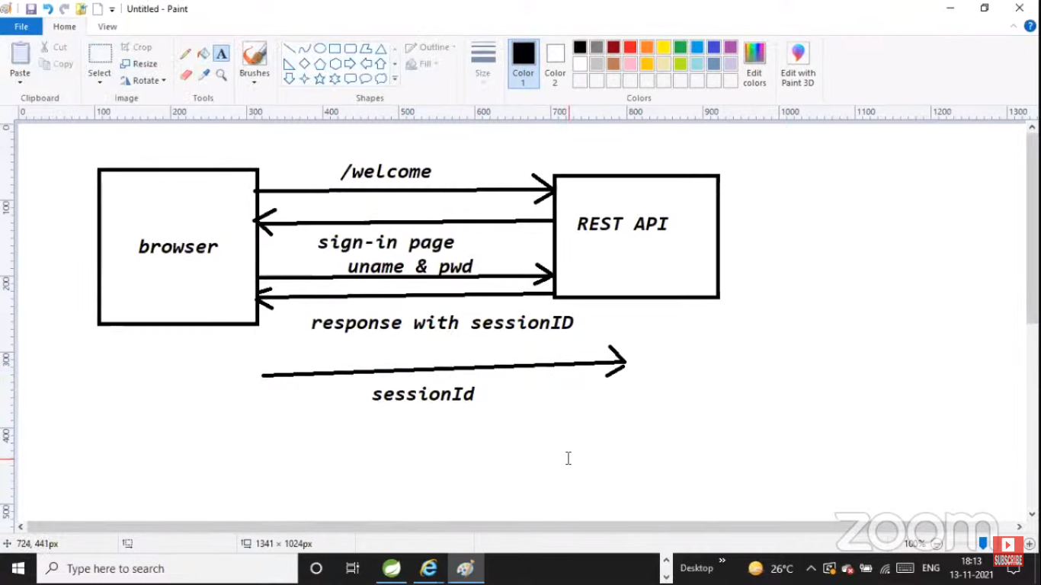









By default spring security will applied for all the endpoints in our app. If we want to customized security for some endpoints alone:-

**Step 1:** Create restController with multiple endpoints

**Step 2:** Configure username and password to avoid the default one

**Step 3:** Create configuration class which will extend WebSecurityConfigurerAdapter and annotate the class @Configuration and @EnableWebSecurity

**Note:** How authentication happen for every req by default: Because of configure method.

Here http.formLogin() 🡪 will be executed for browser

http.httpBasic 🡪 will be executed for other app(eg: postman)

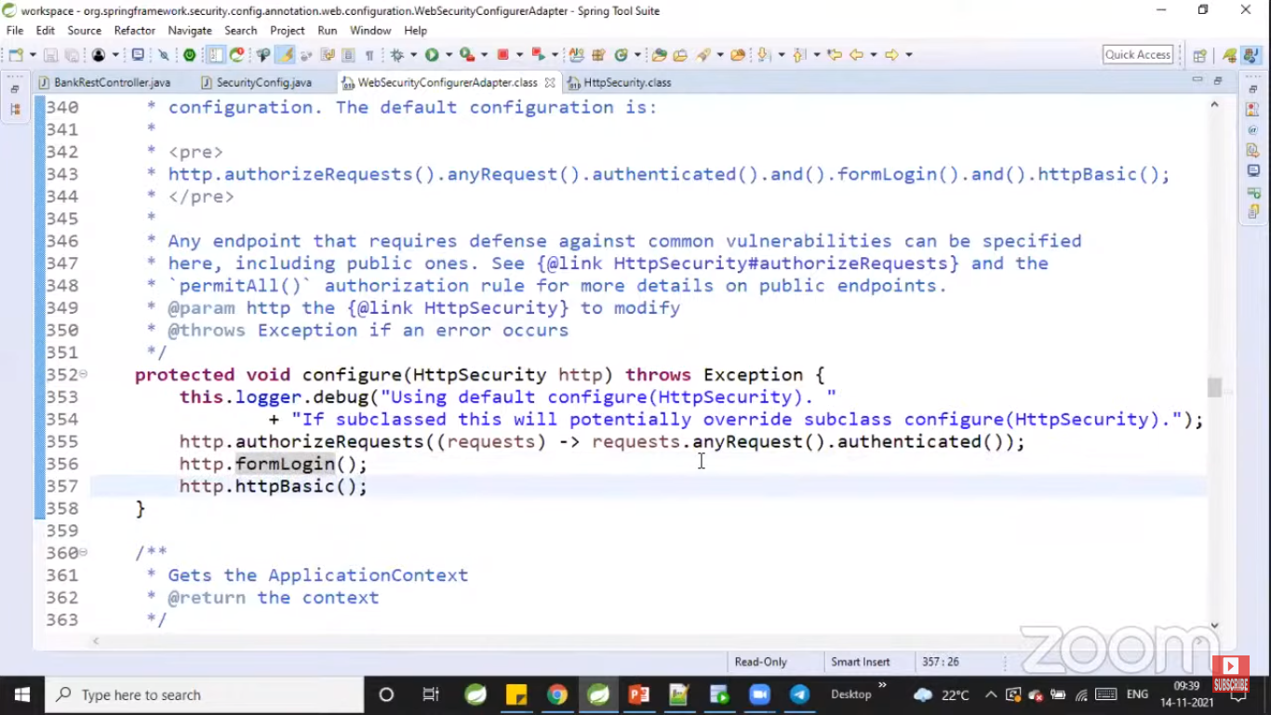

**Step 4:** Customize the security by overriding the configure method:



**Ways to configure multiple users to spring boot security:**

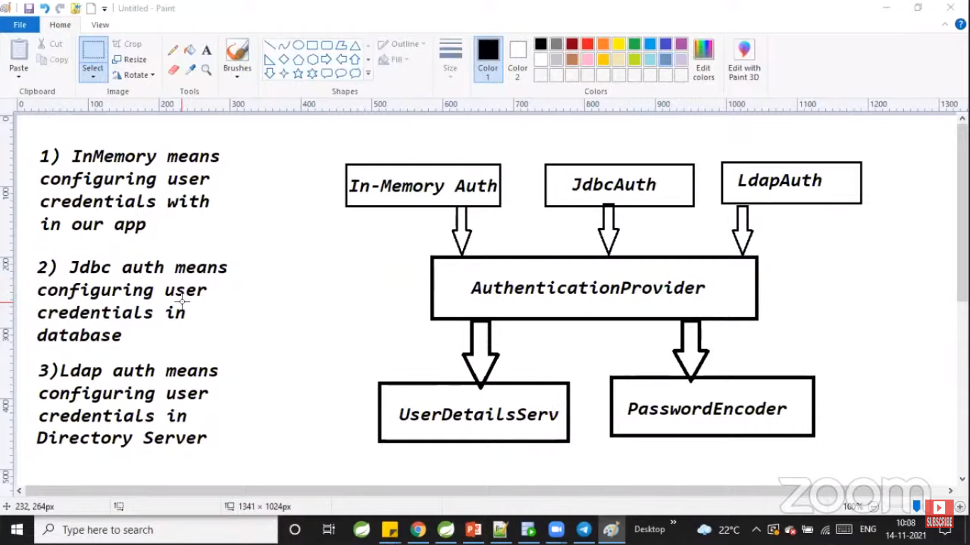

In memory🡪 when limited people going to access our app

JDBC🡪 when more or public people going access our app

LDAP🡪 when in house people going to access our app





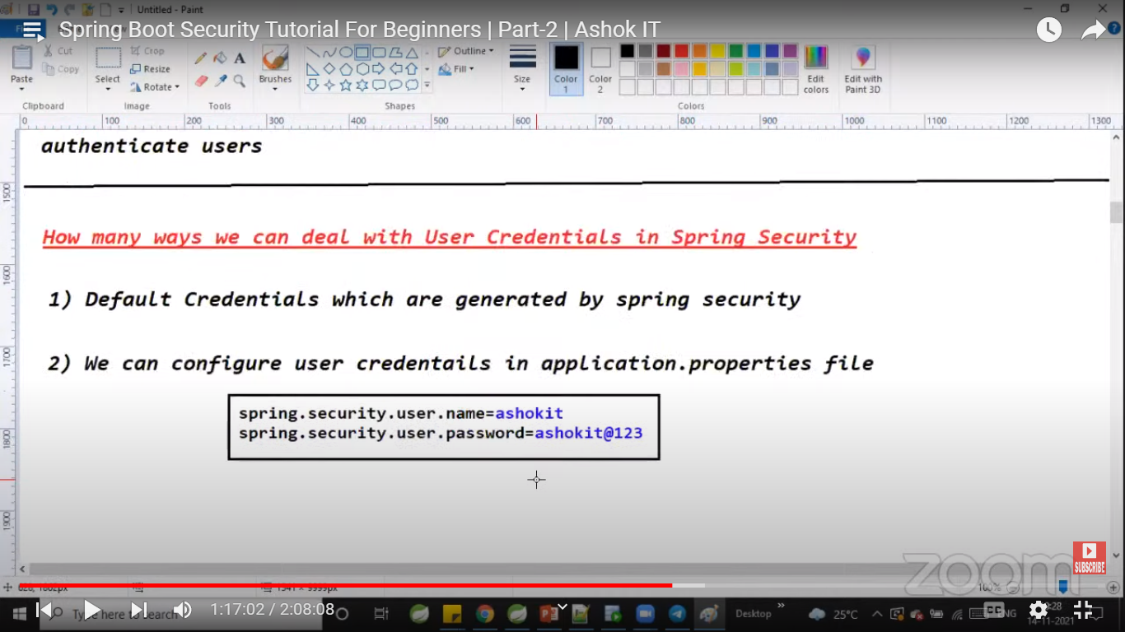



Configure multiple users in in-memory:



Security using JDBC:













